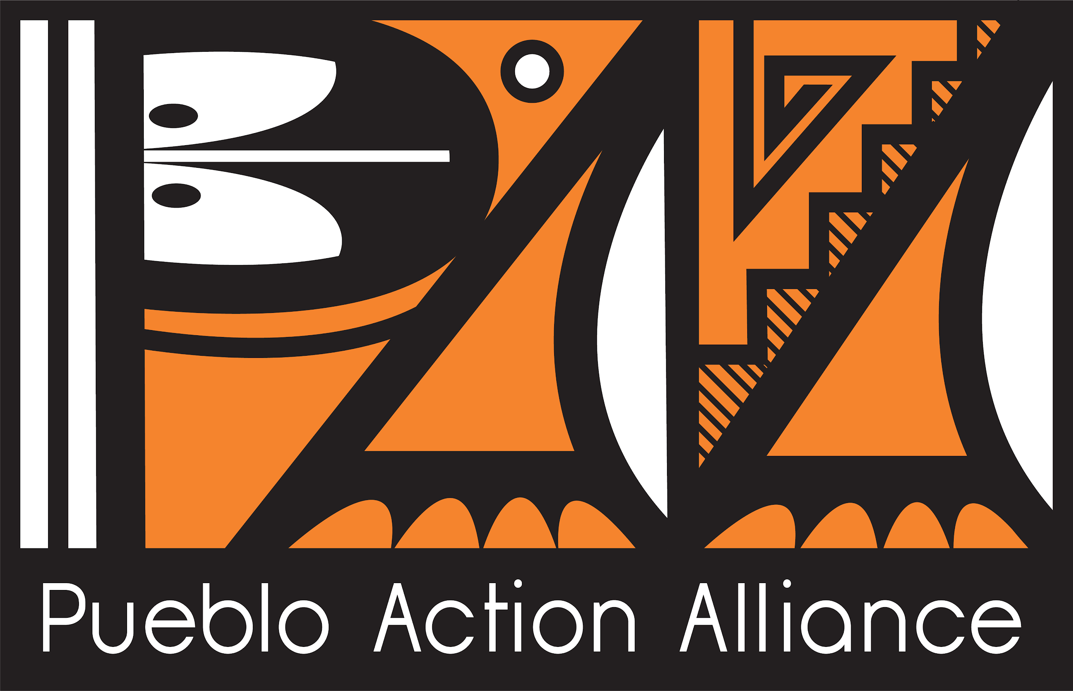
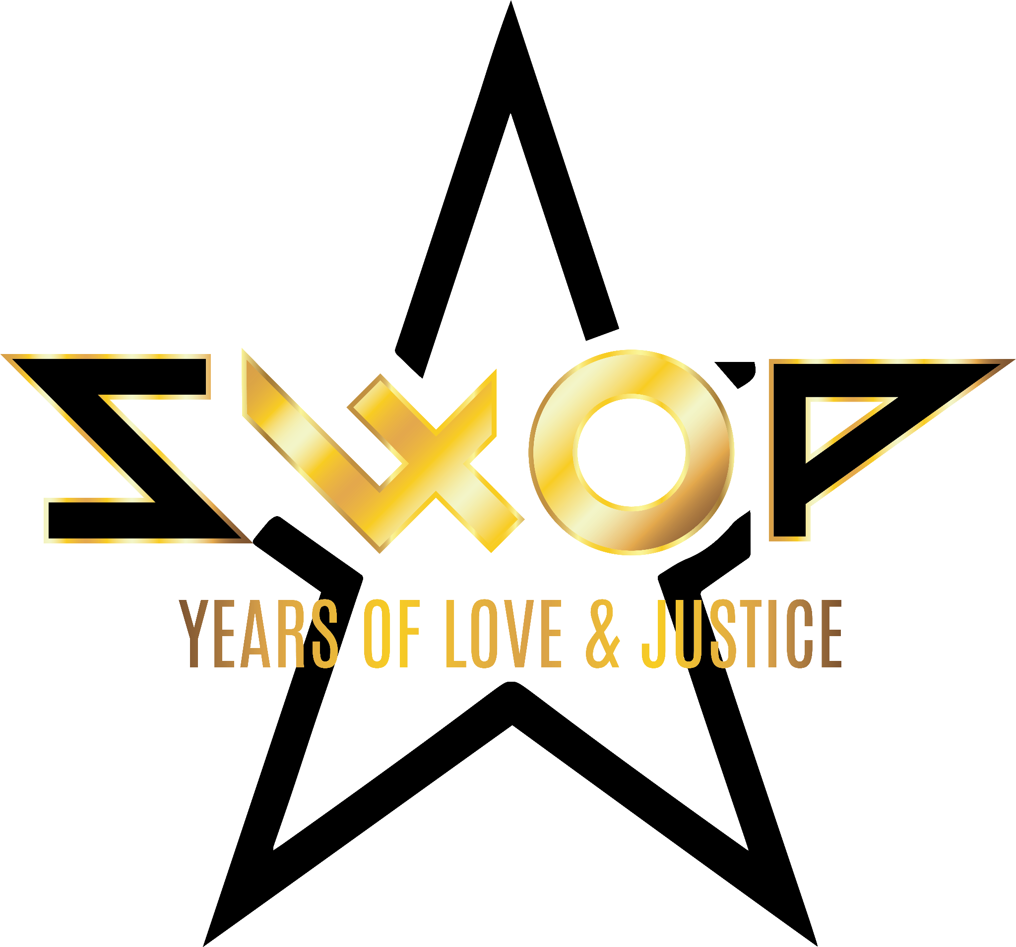
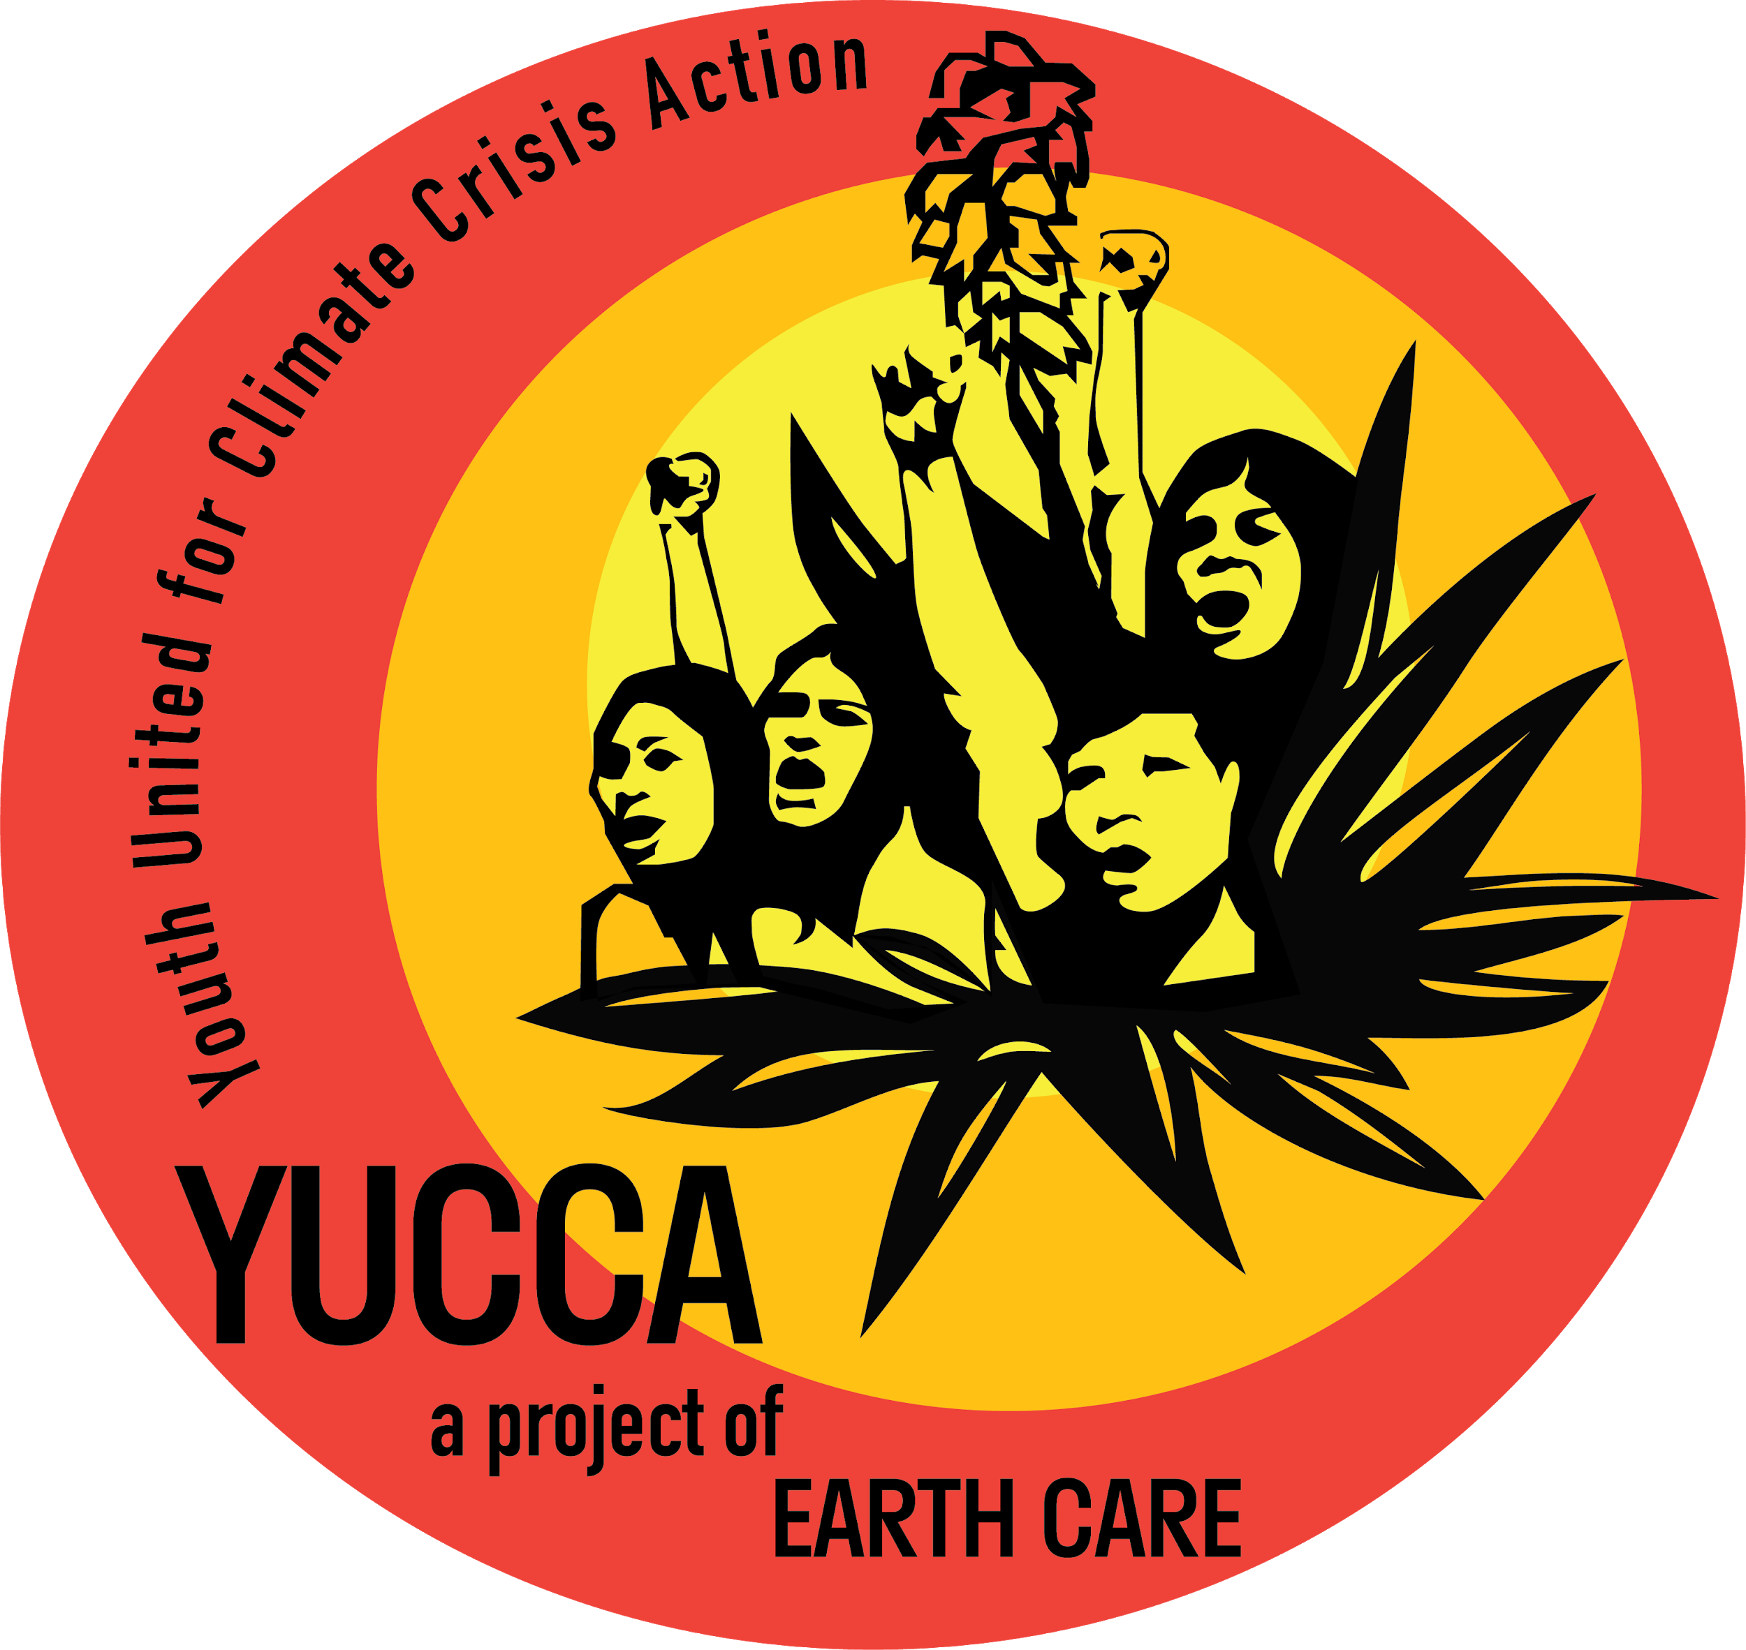

Press Contact:
YUCCA - Youth United for Climate Crisis Action
Seneca Johnson
505-930-6204
yucca@earthcarenm.org

Pueblo Action Alliance
505 220-0051
jula.f.bernal@gmail.com

****FOR IMMEDIATE RELEASE****

INDIGENOUS & OTHER FRONTLINE YOUTH CLIMATE ACTIVISTS
PROTEST FALSE CLIMATE SOLUTIONS
PROPOSED FOR THE 2022 NM STATE LEGISLATIVE SESSION

PHOTOS

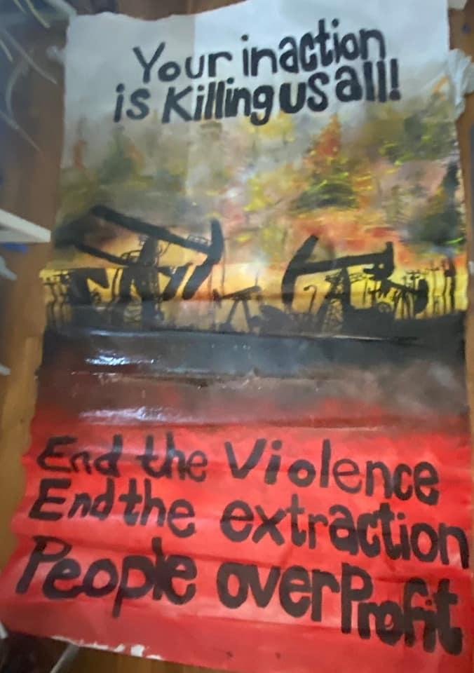
YUCCA (Youth United for Climate Crisis Action) joined by Pueblo Action Alliance and Southwest Organizing Project interrupted Governor Michelle Lujan-Grisham’s speech with banners and chants against hydrogen and other false climate solutions
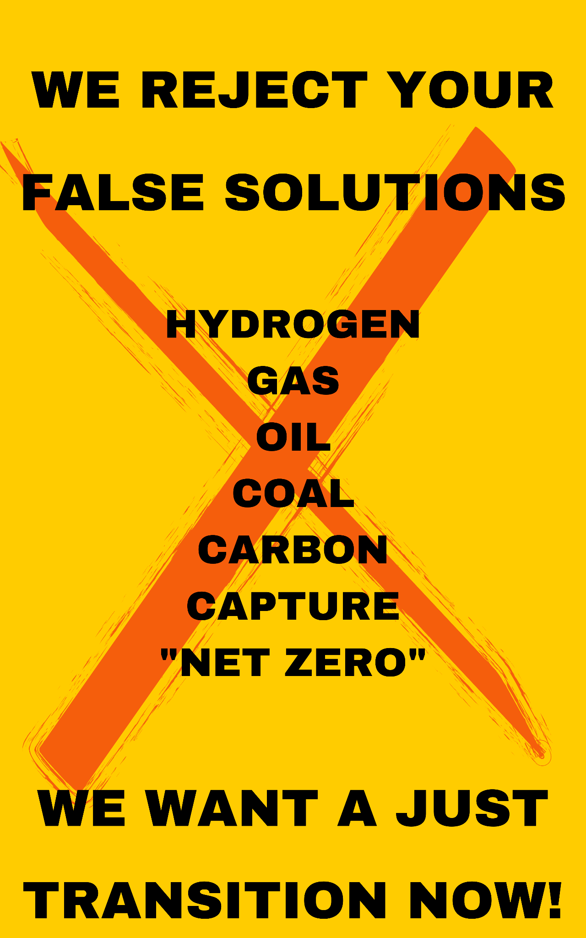
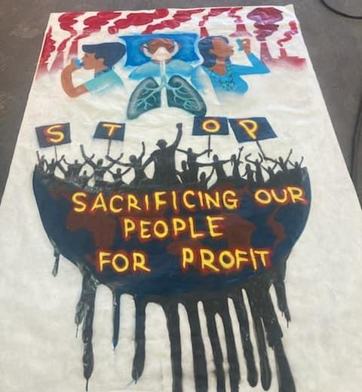

SANTA FE, NM January 18, 2022: Northern New Mexico youth leaders of YUCCA (Youth United for Climate Crisis Action) organized a disruption of Governor Michelle Lujan Grisham’s state of the state address on the first day of the 55th legislative session. Joined by allies - the protestors unfurled banners and chanted with the message that instead of investing in expanding fossil fuel production in the state, we must invest in bold proposals to transition as soon as possible from our fossil fuel dependence and to mitigate the impact of New Mexico’s role in the climate crisis. For the last three years, YUCCA has asked the Governor to introduce Just Transition and Revenue Replacement Strategy legislation as a priority for New Mexico, however, we have not seen adequate measures from the state. Instead, we have only been handed ‘false solutions’ for the 2022 Legislative Session. The Governor’s Legislative Agenda includes plans for New Mexico to achieve net-zero-emissions by 2050, she has already committed New Mexico to test and build out the hydrogen sector - signing agreements with industry to use produced water from fracking to create hydrogen, her plan reduces carbon too slowly and by using false solutions like — carbon capture and offsets - all of which are dangerous false solutions, designed to distract us from taking meaningful climate action and keep the money flowing to the same fossil fuel industries that have spent decades destroying our planet for short-term profits. We call them ‘false solutions’ because these proposals are dangerously disguised as green and sustainable, but the reality is that they only increase New Mexico’s dependency on volatile fossil fuel extraction and its revenue. Blue hydrogen has a 20 percent higher carbon footprint than burning coal or natural gas. No hydrogen is clean hydrogen - whether through fracking or the use of water - hydrogen requires unacceptable resource extraction. We have better options available to us.

“As young New Mexicans we love our state and home. But we are frightened and distressed by the addiction we witness to state revenue from dirty energy. We are frightened by the abusive relationship we witness between our state and extractive and predatory corporate utilities and industry. Our communities want clean energy and we want opportunities to pursue local economic development that don't trade the long term health and livability of our planet for short term and short sighted revenue that comes at the cost of human life and the stability of our climate.We have amazing potential in New Mexico for renewable energy - and we have an amazing responsibility. It hasn’t snowed all winter - it’s been so so dry and so warm. It is so blatantly obvious that our Earth Mother is sick and yet our Governor continues to support oil and gas that is poisoning her and our communities on the frontlines are being sacrificed. This is UNACCEPTABLE. We cannot accept it anymore. ” - Seneca Johnson, YUCCA spokesperson

These proposals are happening at a time when our world’s leading climate scientists have stated unequivocally that we have less than 8 years to cut our carbon emissions in half in order to mitigate the impending climate catastrophe threatening the future of my generation and generations of New Mexicans after us. As a lawmaker in one of the top oil and natural gas-producing states in our country, the responsibility of making science-informed decisions that protect our climate falls on our decision makers.

We urge our state’s representatives to vote against these false solutions, including Representative Lundstrom’s Hydrogen Development Act, Governor Grisham’s Hydrogen Hub Act, and the The Zero Emissions Economy Act - we need real zero not “net” zero.

The latest Intergovernmental Panel on Climate Change Report published in 2021 was clear: Now is the time to take drastic action if we want to mitigate the unimaginable loss of life and displacement, the likes of which our species has never seen before. New Mexican’s from every corner of the State are already feeling the impacts of a warming planet, and we’ve been demanding meaningful climate legislation for years - now’s the time to answer our call.

"Pueblo Action Alliance has held a firm stance against false or green-washed solutions that are being promoted as equitable or viable ways to reduce fossil fuel emissions and address the climate crisis. Indigenous people have been at the forefront of extractive industries since first colonial contact. In so-called New Mexico, the state is moving to implement market-based initiatives to achieve ‘net zero,’ which we constitute as a false solution. Market-based solutions continue to secure fossil fuel economies to crutch oil and gas production. When the state needs to be implementing economic opportunities for renewable energy and achieve real zero greenhouse emissions. This has come from the unified perspective of Indigenous peoples across the globe who are fighting against off-setting programs that include goals to achieve ‘net-zero’ and ‘carbon neutrality.’ These concepts do not fit into the agenda of many Indigenous grassroots movements as they continue their efforts against false solutions. Pueblo Action Alliance will remain in solidarity with the Indigenous global struggle and will continue our effort to end fossil fuel extraction in the Greater Chaco landscape and beyond."

- Pueblo Action Alliance, www.puebloactionalliance.org

“SWOP stands with other grassroots leaders such as Pueblo Action Alliance, Youth United for Climate Crisis Action, along with Earth Care and other NM climate organizations that reflect the state’s diverse frontline communities. Our analysis of the draft Zero Emission Economy Act (HB6) and other false solutions proposed by MLG are that they do NOT put forth any real solutions that will change the current climate paradigm, but instead create an economic dependency on out-of-state entities. Rather than investing in a regenerative economy, centered on homegrown solutions, HB6 reflects the ideals of the fossil fuels industry and private stakeholders to advance market mechanisms while profiting off pollution. This proposal will not lower consumption, net-zero and other market-based mechanisms have been shown to INCREASE consumption by those who can afford to pay for the proposed “carbon sequestration and offsets”. The bottomline is that this bill as written will do more harm than good, and by accepting net-zero as a climate solution we endanger the future of our state.”

- Alejandría Lyons, EJ Organizer SouthWest Organizing Project, www.swop.net

********
YUCCA's mission is to organize a youth-led intergenerational & intersectional grassroots climate justice movement in NM that is powerful enough to hold leaders accountable and force the passage of climate policies that address the science, move us swiftly and justly toward carbon neutrality, and end our abusive dependence on fossil fuel extraction.
For more information visit https://www.yuccanm.org/

